Dr.V.P.Shetkari Shikshan Mandal's

PADMABHOOSHAN VASANTRAODADA PATIL INSTITUTE OF TECHNOLOGY,

BUDHGAON:-416 304.

DEPARTMENT OF ELECTRONICS ENGINEERING



A

Synopsis on

“AUTUMATIC MULTIPURPOSE AGRI ROBOT”

|  |  |  |
| --- | --- | --- |
| **Sr.NO.** | **Name** | **Roll No.** |
| 1. | Miss.Dhulubulu Sneha Mahaling | 15 |
| 2. | Miss. Pise Geetanjali Dhondiram | 16 |
| 3. | Mr. Shinde Rahul Bhagwat | 17 |

Academic Year

2015-2016

Prof.K.K.Pandyaji Prof.J.A.Shaikh Prof.Dr.S.V.Joshi

GUID E H.O.D. Principal

**Index:-**

|  |  |  |
| --- | --- | --- |
| Sr.No. | Title | Page No. |
| 1 | Abstract |  |
| 2 | Introduction |  |
| 3 | Literature Survey |  |
| 4 | Proposed work-   1. Block diagram 2. Facilities Available 3. Approximate expenditure |  |
| 5 | Futures Scope |  |
| 6 | Reference |  |

**1] Abstract:-**

Solar based grass cutter with sprinkler system states an idea to use the abundantly available solar power in a very unique method for reducing human efforts in a Garden/cricket ground/Football ground/ All Play ground/Park /farm. This concept explains how technology can be used to reduce human efforts as well as to efficiently utilize renewable sources of energy. A detailed documentation of a Solar Powered Gardner has been made.

**2] Introduction:**

Solar Energy is one of the most abundantly available forms of energy exposed to humans. A large part of this energy gets wasted. Efficient use of Solar Energy can significantly reduce the scarcity of our day to day energy requirement for present as well as future generations. An example of how solar energy can be harvested by implementing it with the available technology is shown with an example of solar powered Gardner.

The Solar Powered Gardner is an automated grass cutting robotic vehicle powered by solar energy. It is designed such that it can avoid the obstacles automatically, while carrying out its operations of grass cutting and/or water sprinkling. The system uses 12V batteries to power the robotic assembly. A Solar Panel is used to charge these batteries. An Atmega16 controller is used as the brain of the system. The grass cutter, water sprinkler motors and the wheel motors are interfaced to the microcontroller that controls the working of all the motors. Detection of objects is a very important factor for safety of the assembly as well as human safety, so the micro controller is interfaced with a sensor unit that carries out object detection. On detection of object or obstacle a preprogrammed action is taken by the controller as per the conditions sensed by the sensor.

**3] Literature Survey:**

This paper basically focuses on the proposal for reduce the man power and usage of electricity. Maximum power point tracking technique is used to improve the efficiency of the solar panel. The DC to DC buck boost converter helps to step up the DC voltage from the photovoltaic panel and store the DC voltage in a battery. It is an automated system for the purpose of grass cutting and sprinkling. The source is drive from the solar energy by using photovoltaic panels. The DC-DC converter is used to convert the low level DC voltage into the high level DC voltage. High level DC voltage helps to operate the whole system. The system control is done by the Arduino. Automation is achieved by using ultrasonic sensors and Arduino. Wheels and cutting operations are done using dc motors. DC battery is utilized for powering and standby mode operation of the system.

**4] Proposed Work:**

The designing of such a system uses interfacing of various electronic components together. The implemented system uses a microcontroller as it control unit, a sensor microcontroller interface is required and a motor to microcontroller interface is required along with a LCD panel interfaced to the controller. All this is powered by two batteries providing a required output; these batteries are charged by using the Solar panel.

The components used are a Solar panel of capacity 12 V 10 Watt,

12 V 7 Amp batteries, DC Motor , Pump Motor, Arduino , Motor Driver, Ultrasonic sensor, Flood sensor etc.

1. **Block Diagram:-**

Pump Motor

Cutter Motor

Motor

Water tank

Motor driver

Motor driver

Alarm

Motor driver

Flood sensor

Mode software

Battery

Solar panel

Microcontroller / Arduino

Ultrasonic sensor

Power supply

Microcontroller

ZIGBEE

1. **Facilities Available:-**
2. **Arduino:**

The Arduino Uno is a microcontroller board based on the ATmega328 (datasheet). It has 14 digital input/output pins (of which 6 can be used as PWM outputs), 6 analog inputs, a 16 MHz ceramic resonator, a USB connection, a power jack, an ICSP header, and a reset button. It contains everything needed to support the microcontroller; simply connect it to a computer with a USB cable or power it with a AC-to-DC adapter or battery to get started.

The Uno differs from all preceding boards in that it does not use the FTDI USB-to-serial driver chip. Instead, it features the Atmega16U2 (Atmega8U2 up to version R2) programmed as a USB-to-serial converter. Revision 2 of the Uno board has a resistor pulling the 8U2 HWB line to ground, making it easier to put into DFU mode. Revision 3 of the board has the following new features:

* Pin out: added SDA and SCL pins that are near to the AREF pin and two other new pins placed near to the RESET pin, the IOREF that allow the shields to adapt to the voltage provided from the board. In future, shields will be compatible both with the board that use the AVR, which operate with 5V and with the Arduino. Due that operate with 3.3V. The second one is a not connected pin that is reserved for future purposes.
* Stronger RESET circuit.
* At mega 16U2 replace the 8U2.

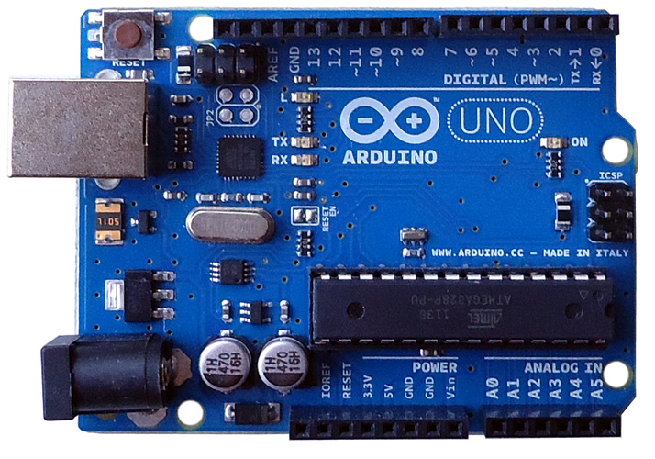

**Fig. Arduino Uno**

1. **Ultrasonic sensor:**

Ultrasonic ranging module HC - SR04 provides 2cm - 400cm non-contact measurement function, the ranging accuracy can reach to 3mm. The modules includes ultrasonic transmitters, receiver and control circuit.

The basic principle of work:

(1) Using IO trigger for at least 10us high level signal,

(2) The Module automatically sends eight 40 kHz and detect whether there is a pulse signal back.

(3) IF the signal back, through high level , time of high output IO duration is the time from sending ultrasonic to returning.

Test distance = (high level time velocity of sound (340M/S) / 2, An ultrasonic sensor transmit ultrasonic waves into the air and detects reflected waves from an object. There are many applications for ultrasonic sensors, such as in intrusion alarm systems, automatic door openers and backup sensors for automobiles. Accompanied by the rapid development of information processing technology, new fields of application, such as factory automation equipment and car electronics, are increasing and should continue to do so. Using its unique piezoelectric ceramics manufacturing technology developed over many years, Murata has developed various types of ultrasonic sensors which are compact and yet have very high performance. The information contained is this catalog will help you to make effective use of our ultrasonic sensor.

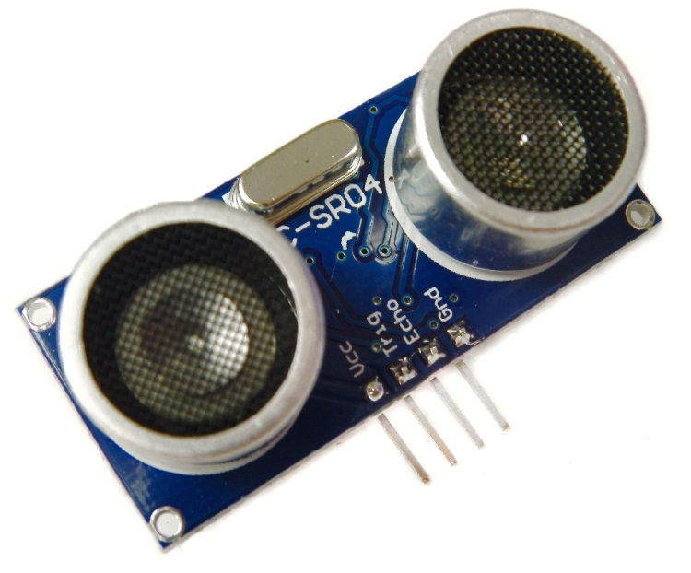

**Fig . Ultrasonic Sensor**

**3) SOLAR PANAL:**

Solar power is the conversion of [sunlight](https://en.wikipedia.org/wiki/Sunlight) into [electricity](https://en.wikipedia.org/wiki/Electricity), either directly using [photovoltaic](https://en.wikipedia.org/wiki/Photovoltaics) (PV), or indirectly using [concentrated solar power](https://en.wikipedia.org/wiki/Concentrated_solar_power) (CSP). Concentrated solar power systems use [lenses](https://en.wikipedia.org/wiki/Lens_%28optics%29) or [mirrors](https://en.wikipedia.org/wiki/Mirrors) and tracking systems to focus a large area of sunlight into a small beam. Photovoltaic’s convert light into an [electric current](https://en.wikipedia.org/wiki/Electric_current) using the [photovoltaic effect](https://en.wikipedia.org/wiki/Photovoltaic_effect). The [International Energy Agency](https://en.wikipedia.org/wiki/International_Energy_Agency) projected in 2014 that under its "high renewable" scenario, by 2050, solar photovoltaic’s and concentrated solar power would contribute about 16 and 11 percent, respectively, of the [worldwide electricity consumption](https://en.wikipedia.org/wiki/Worldwide_electricity_consumption), and solar would be the world's largest source of electricity. Most solar installations would be in [China](https://en.wikipedia.org/wiki/Solar_power_in_China) and [India](https://en.wikipedia.org/wiki/Solar_power_in_India).

Photovoltaic were initially solely used as a source of [electricity](https://en.wikipedia.org/wiki/Electricity) for small and medium-sized applications, from the [calculator](https://en.wikipedia.org/wiki/Amorphous_silicon#Solar_cells) powered by a single solar cell to remote homes powered by an [off-grid](https://en.wikipedia.org/wiki/Off-grid) rooftop PV system. As the cost of solar electricity has fallen, the number of grid-connected [solar PV systems](https://en.wikipedia.org/wiki/Solar_PV_systems) has [grown into the millions](https://en.wikipedia.org/wiki/Growth_of_photovoltaics) and utility-scale [solar power stations](https://en.wikipedia.org/wiki/Photovoltaic_power_station) with hundreds of megawatts are being built. Solar PV is rapidly becoming an inexpensive, low-carbon technology to harness [renewable energy](https://en.wikipedia.org/wiki/Renewable_energy) from the Sun.

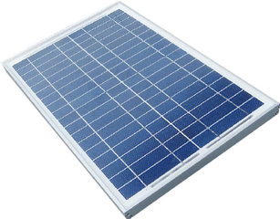

**Fig. Solar Panel**

**4) D C Motor:-**

A DC motor is any of a class of electrical machines that converts direct current electrical power into mechanical power. The most common types rely on the forces produced by magnetic fields. Nearly all types of DC motors have some internal mechanism, either electromechanical or electronic, to periodically change the direction of current flow in part of the motor. Most types produce rotary motion; a linear motor directly produces force and motion in a straight line.

DC motors were the first type widely used, since they could be powered from existing direct-current lighting power distribution systems. A DC motor's speed can be controlled over a wide range, using either a variable supply voltage or by changing the strength of current in its field windings. Small DC motors are used in tools, toys, and appliances. The universal motor can operate on direct current but is a lightweight motor used for portable power tools and appliances. Larger DC motors are used in propulsion of electric vehicles, elevator and hoists, or in drives for steel rolling mills. The advent of power electronics has made replacement of DC motors with AC motors possible in many applications.

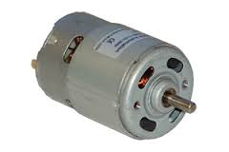

**Fig . D C motor**

**5) Battery:**

An electric battery is a device consisting of one or more electrochemical cells with external connections provided to power electrical devices such as flashlights, smartphones, and electric cars. When a battery is supplying electric power, its positive terminal is the cathode and its negative terminal is the anode. The terminal marked negative is the source of electrons that when connected to an external circuit will flow and deliver energy to an external device. When a battery is connected to an external circuit, electrolytes are able to move as ions within, allowing the chemical reactions to be completed at the separate terminals and so deliver energy to the external circuit. It is the movement of those ions within the battery which allows current to flow out of the battery to perform work.Historically the term "battery" specifically referred to a device composed of multiple cells, however the usage has evolved to additionally include devices composed of a single cell.

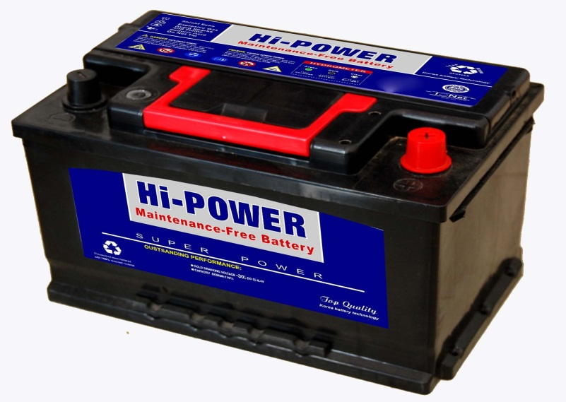

**Fig. Battery**

**6) Motor driver:-**

A motor driver is a little current amplifier; the function of motor drivers is to take a low-current control signal and then turn it into a higher-current signal that can drive a motor.

The L293 and L293D devices are quadruple high. The L293 is designed to provide bidirectional drive currents of up to 1 A at The L293D is designed to drive inductive loads such as relays, solenoids, DC and bipolar stepping motors, as well as Per Channel (1.2 A for other high-current/high-voltage loads in positive L293D) supply applications. for Inductive.

Transient each output is a complete totem-pole drive circuit, Suppression (L293D) with a Darlington transistor sink and a pseudo Darlington source. The L293D is Motor driver IC. The L293 and L293D are characterized for operation.

1. **Approximate expenditure**

|  |  |  |  |  |
| --- | --- | --- | --- | --- |
| **Sr.No.** | **Name Of Component** | **Specification** | **Quantity** | **App. Cost** |
| 1 | Solar panel | 12V; 10 Watt | 1 |  |
| 2 | DC Motor | 12V ; 100 rpm | 4 |  |
| 3 | DC Motor | 12V ; 10000 rpm | 1 |  |
| 4 | Pump Motor | 12V | 1 |  |
| 5 | Motor Driver | L293D | 6 |  |
| 6 | Arduino | Atmega328 uc | 1 |  |
| 7 | Ultrasonic Sensor | - | 1 |  |
| 8 | Flood Sensor | - | 1 |  |
| 9 | Fan Type Cutter | - | 1 |  |
| 10 | LCD Panel | 16*2 | 1 |  |
| 11 | Alarm, Resister, Capacitor, Regulator, etc | - | - |  |

**5] Futures Scope:-**

1. The project which we have done surly reaches the average families because the grass can be trimmed with minimum cost and with minimum time Finally this project may give an inspiration to the people who can modify and can obtain better results.

2. Also we can use X-Bee for a wireless handling and GPS used for problem detection of our System.

**6] Reference:-**

[1] “ AUTOMATIC GRASS CUTTING MACHINE BY USING PHOTOVOLTAIC SOURCE AND MOTOR SPEED CONTROL”, " Mr. P. PUGAZHENDIRAN”, “Mr. A. BHARANEETH”, & “N. MOHAMEDNIZAR” Associate professor /HOD OF EEE1 Senior Assistant professor2 UG scholar3

[2] “Photo physics of Bio-Inspired Solar Energy Conversion”, by Robert Schmitz “ ARIZONA STATE UNIVERSITY May 2014”

[3] “Design and implementation of autonomous Lawn-Mower Robot controller”, “Wasif, M ; Dept. of Electr. Eng., Univ. of Gujrat, Gujrat Print ISBN: 978-1-4577-0769-8.

[4] Jason Smith, Scott Campbell and Jade Morton "Design and Implementation of a Control Algorithm For an Autonomous Lawnmower", *Circuits and Systems, 48th Midwest Symposium on Digital Object Identifier*, vol. 1, pp.456 -459.